YAA Performance Squad 2010-11
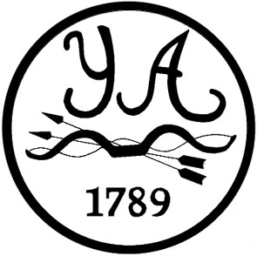


Goal Setting

What I want to achieve in 2011 (perhaps classifications, score levels etc)
1

2

3

What do I need to do to achieve this in terms of improving my technique?
1

2

3

What could I do to improve my performance in competitions?
(could include fitness/stamina, focus, relaxation, diet, preparation)
1

2

3

Is there anything I need to do with, or make changes to, my equipment?

Is there anything else that I can do to contribute to my success?

What might I need help with, and where can I get this help from?

